MWAA
Fall Meeting
October 17, 2014

Racine Wastewater Utility
SC Johnson Wax research lab tower and landmarks tour.

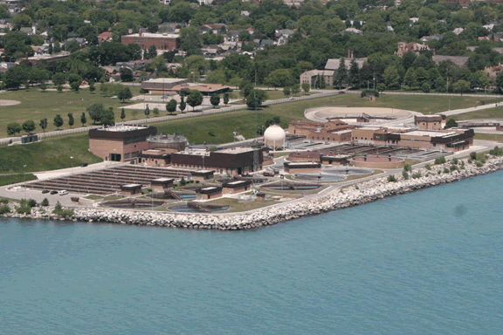 | The Officers and Board of the Midwest Water Analysts Association are proud to host the Fall Meeting  Friday, October 17, 2014

Racine Wastewater Utility
2101 Wisconsin Ave
Racine, Wisconsin 53403
The Racine Wastewater Treatment Plant is a conventional activated sludge plant with chemical phosphorus precipitation, anaerobic sludge digestion, belt filter press dewatering and ultraviolet disinfection of effluent. The design average flow is 36 MGD.
The laboratory at the Racine Wastewater Treatment Plant is a WDNR certified laboratory, which provides analytical support for regulatory compliance and plant process control, the Industrial Pretreatment Program and hauled waste monitoring.
No open toed footwear permitted

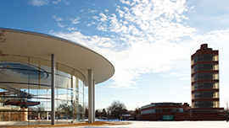

SC Johnson - THE LANDMARKS TOUR
Tours begin at The Golden Rondelle Theater, at 1525 Howe Street, Racine, Wisconsin, 53403
Highlighted by the opening of the Frank Lloyd Wright-designed Research Laboratory Tower, the Landmarks Tour is perfect for those who want a close, in-depth look at SC Johnson’s inspired architecture.
This tour also features the Wright-designed Administration Building as well as the award-winning Foster + Partners-designed Fortaleza Hall, with the Spirit of Carnaúba airplane soaring at its heart, and a visit to The SC Johnson Gallery: At Home with Frank Lloyd Wright.
(Exterior photography for personal use is permitted. Interior photography is prohibited, as is the use of any video during tours)

Fall Meeting 2014 Schedule of Events

10-17-2014
11:00-11:30pm Registration at entrance to Racine Wastewater Utility

11:30-1:30pm Tour of the facility

2:00- 4:30 pm Tour of SC Johnson Frank Lloyd Wright-designed Research Laboratory Tower and other landmarks at facility.

5:00pm Dinner at Salute’ Italian Restaurant www.saluteitalianrestaurant.com/index.html
314 Main St Racine WI

-Registration limited to first 32 persons-

REGISTRATION FOR MWAA FALL MEETING 2014
***************************************************************************
REGISTRATION COST INCLUDES DINNER!
Regular Registration Student & Retiree

Advance registrations (please circle) $25 $15
Staying for dinner? (please circle) Yes No

***************************************************************************

Name:
Facility:
Address:
Phone Number:
Fax Number:
E-Mail Address:

Payment Method: In Advance ( ) At the door ( )

Personal Check ( ) Facility Check ( ) Cash ( )

Checks should be mailed to:
Sue Sutherland, 250 W. Seeboth, Milwaukee, WI 53204
Registrations may be sent via US mail, e-mailed to ssutherland@mmsd.com or faxed to (414) 225-2266. Questions? Call Sue Sutherland at (414) 225-2166.

DIRECTIONS:

To Racine Wastewater Utility, 2101 Wisconsin Ave
Racine, Wisconsin

From either north or south Via I 94
1. Exit HWY 11(Durand Ave) Racine (# 335)
2. East approximately 8 miles to Sheridan Rd (HWY 32)
3. Turn Left, then take second Right on 24th St.
4. Continue onto Roosevelt Park Dr
5. Right onto 21st St. entrance on right.

Alternatively you may exit at HWY KR, first exit south of HWY 11, head east to Sheridan Rd (32)
Turn left and travel approximately 2 miles (will cross Durand Ave (HWY 11)), then follow directions from #3 above

This is a more rural route so less signals etc = quicker.

From Racine Wastewater Utility to SC Johnsons (Golden Rondelle Theatre).

Exit Utility and follow lakefront north on Wisconsin avenue

Turn left on 14th St. go 6 blocks (Franklin St on right)

Entrance to Golden Rondelle on the left

From Golden Rondelle to Salute’ Restaurant
Turn right onto 14th St 0.5 mi/745 m
Bear left onto S Main St 1.0 mi/1.6 km
Your destination on S Main St (WI-32) is on the left.
Parking is available on street or parking garage nearby on east side of Street.

Information on future and past meetings is posted on the web site (www.midwestwateranalysts.org), as well as links to related sites and other information. Check out our new Facebook page, too!

Effective January 2012

OFFICERS

President Rebecca Rose Metropolitan Water Reclamation District of Greater Chicago
6001 West Pershing Road
Cicero, IL 60804
708-588-3782 rebecca.rose@mwrd.org

First VP Bill Fowler Advanced Waste Services
3801 L W McKinley Ave
Milwaukee WI 53208
414-397-2265 123louie@att.net

Second VP Tricia Stefanich Metropolitan Water Reclamation District of Greater Chicago
6001 West Pershing Road
Cicero, IL 60804
708-588-4118 tricia.stefanich@mwrd.org

Secretary Diane Moe Metropolitan Water Reclamation District of Greater Chicago
6001 West Pershing Road
Cicero, IL 60804
708-588-4050 diane.moe@mwrd.org

Treasurer Larry Dressel DuPage County Public Works (retired)
6 South 045 Timberlane Drive
Naperville, IL 60563-1072
630-369-5586 larrydressel@juno.com

Immediate Sarah Miller Metropolitan Water Reclamation District of Greater Chicago
Past President 6001 West Pershing Road
Cicero, IL 60804
708-588-3675 sarah.miller@mwrd.org

STEERING COMMITTEE

Rob Flood North Shore Sanitary District
(Past President) William Koepsel Drive
Gurnee, IL 60031
847-623-6060 roflood@northshoresanitary.org

Steve Foreen 847-864-3927 foreen8@aol.com

Marla Gabie 934 Dodge, Evanston, IL 60202

847-830-5649 mgabie2001@yahoo.com

Paul Poshyvanyk Metropolitan Water Reclamation District of Greater Chicago
6001 West Pershing Road, Cicero, IL 60650
708-588-3738 paul.poshyvanik@mwrd.org

Norm Rose Metropolitan Water Reclamation District of Greater Chicago (retired)
(Past President) 630-960-2786 nrose835@sbcglobalnet

Sue Sutherland Milwaukee Metropolitan Sewerage District
(Past President) 250 W. Seeboth
Milwaukee, WI 53204
414-225-2166 ssutherland@mmsd.com

Dan L. Aderholdt Crossbow Water
320 West 194th Street
Glenwood, IL 60425
708-408-3059 dan@crossbow-water.com

Donna Coolidge Metropolitan Water Reclamation District of Greater Chicago
6001 W. Pershing Rd.
Cicero, IL 60804
708-588-4064 donna.coolidge@mwrd.org

Jenny Irby Milwaukee Water Works
3000 N. Lincoln Memorial Dr.
Milwaukee, WI 53211
414-286-2880 Jenny.L.Irby@milwaukee.gov

Mitch Olds Milwaukee Metropolitan Sewerage District
250 W. Seeboth
Milwaukee, WI 53204
414-225-2258 molds@mmsd.com

